**Penguin Jumper**

1. Delete Sprite 1 (the cat)
2. Paint the following backdrop as a bitmap image

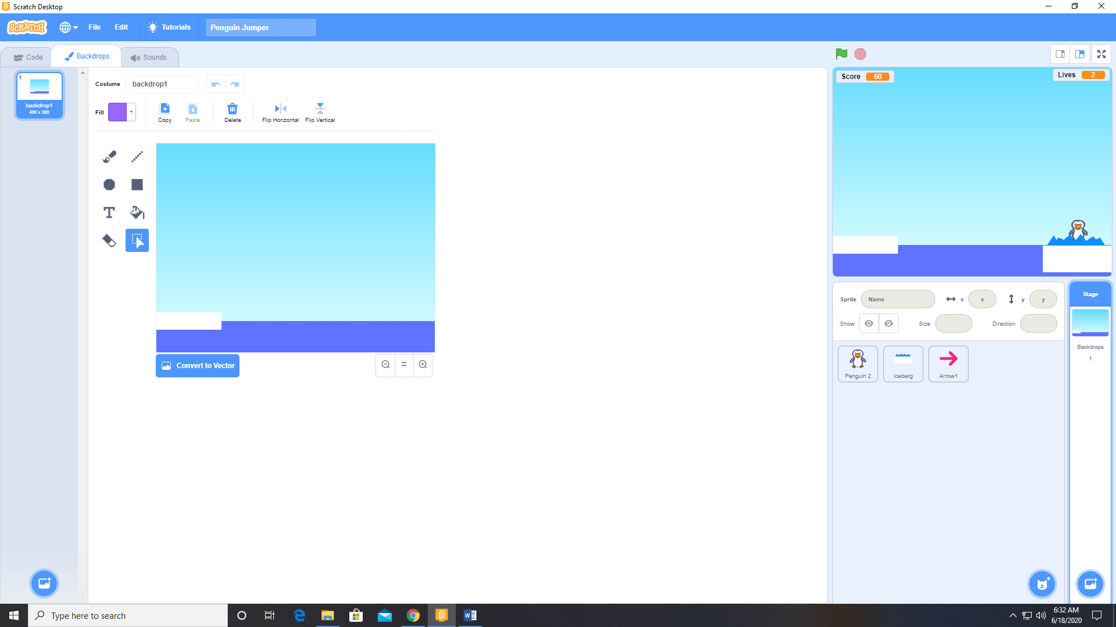

1. Add a sprite (Penguin 2) from the sprite library
2. Add the variables (Score, Lives, Vspeed, Hspeed, Vgap, Hgap) available to all sprites with Scores and Lives visible on the stage.
3. Create a MovePenguinToStart function for the Penguin 2 sprite.

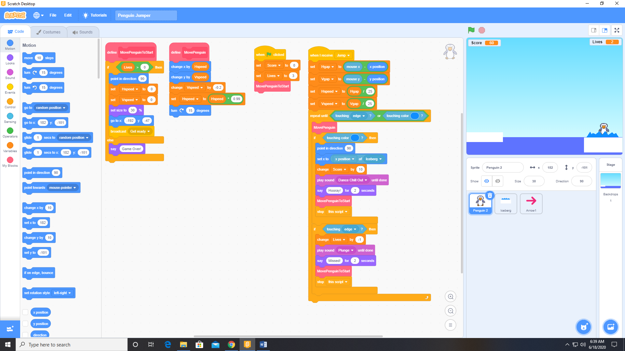

1. Create a MovePenguin function for the Penguin 2 sprite.

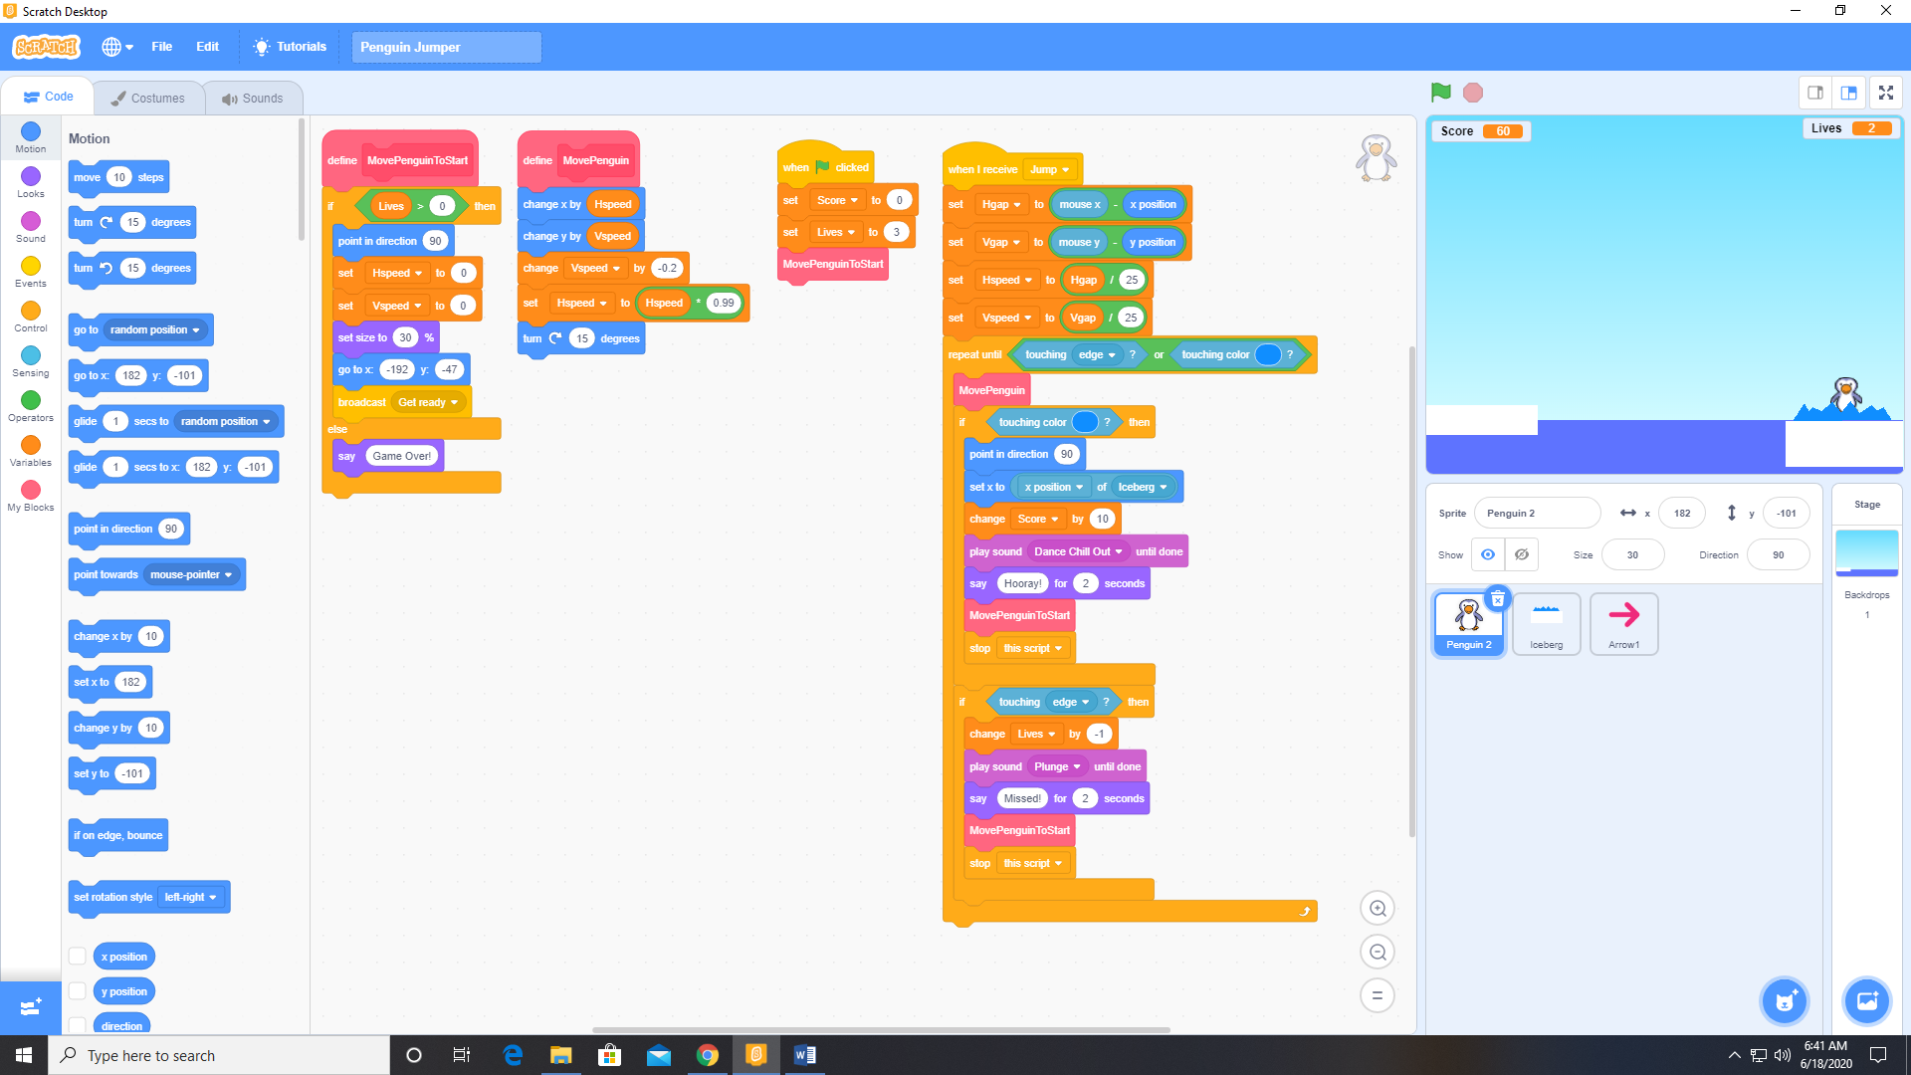

1. Add the Dance chill out and Plunge sounds to the Penguin 2 sprite from the sound library.
2. Paint an Iceberg sprite as a bitmap image.

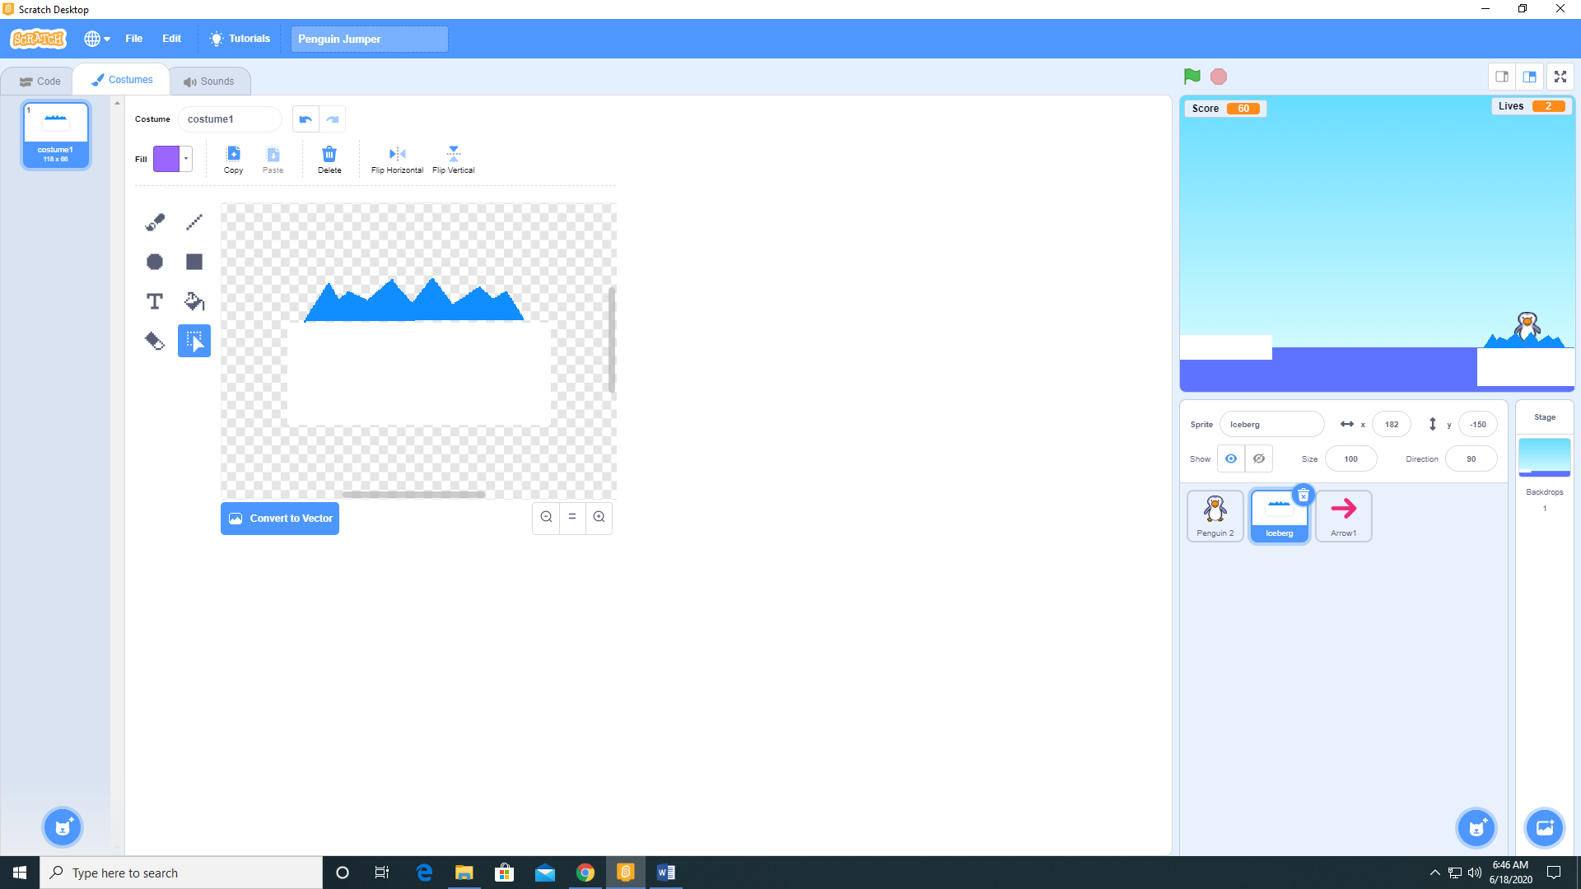

1. Add a sprite (Arrow 1) from the sprite library.
2. Add the following code to the Arrow 1 sprite.

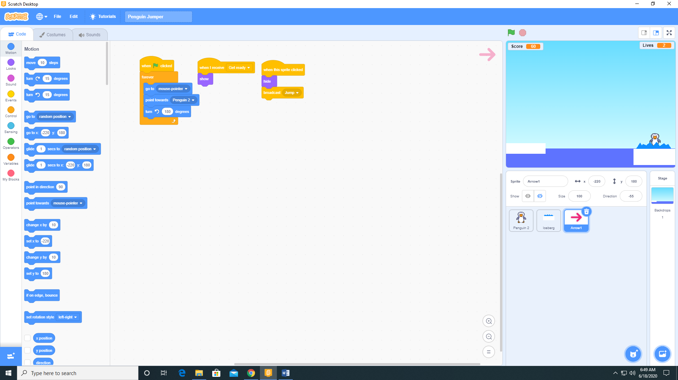

1. Add the following code to the Iceberg sprite.

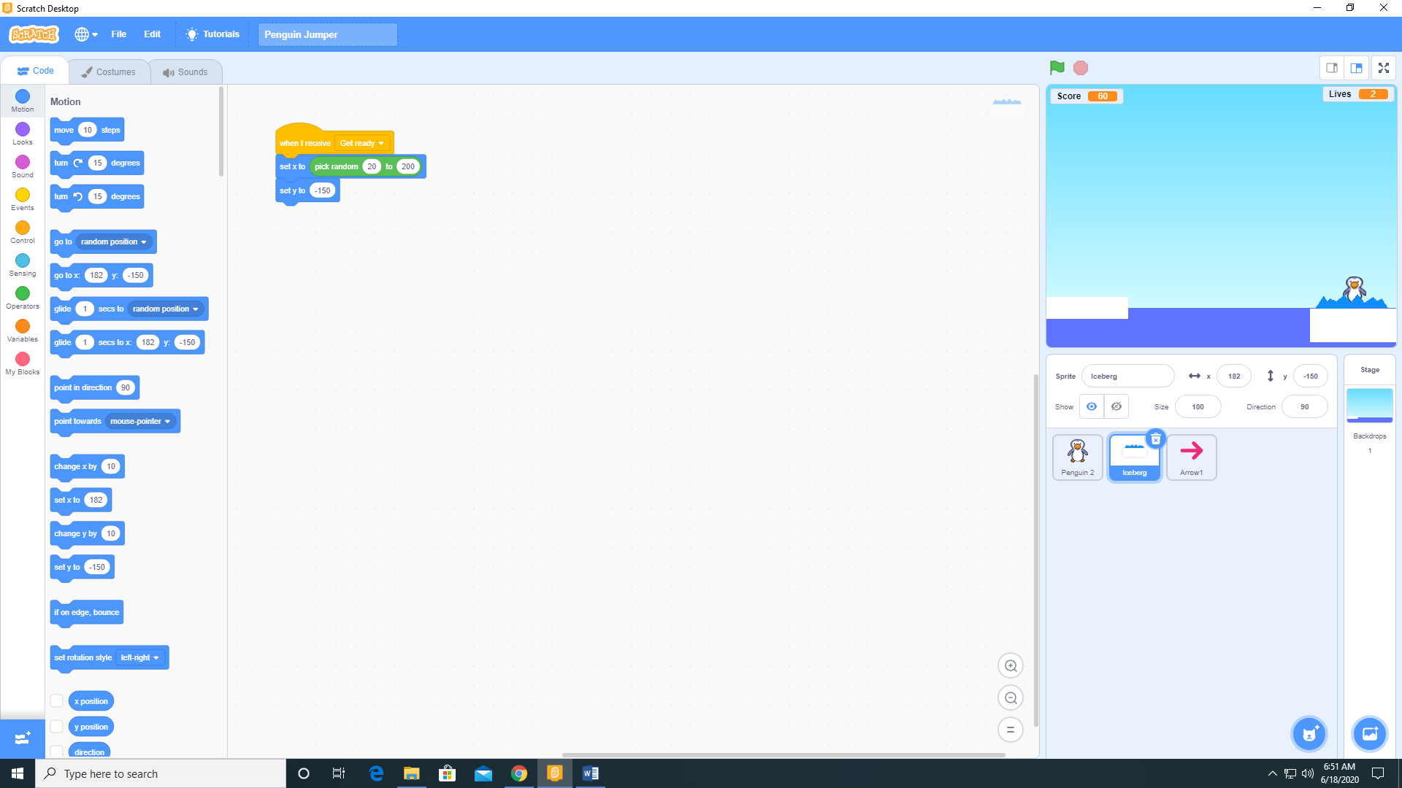

1. Add the following code to the Penguin 2 sprite.

